TN7.0 Flow for Ac Module

Version 0.1

Revision History
H
Date | Version | Description | Author
5/5/2011 | 0.1 | Initial Draft | Wang Guibing

Table of Contents
1 Ac 4
1.1 AcController init flow 4
1.2 Find current location flow 4
1.3 Home/Work/Address flow 5
1.4 AirportController flow 6
1.5 ContactsController flow 7
2 OneBoxSearch 8
2.1 OneBoxSearch flow 8

Ac

AcController init flow
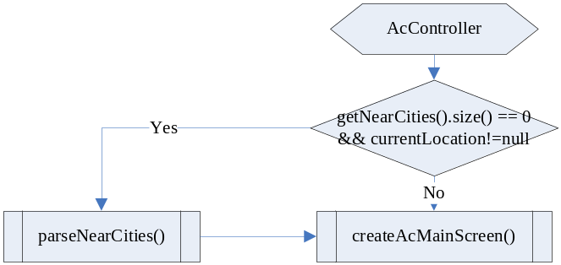
In Ac main screen, you can do those things as follow:
- Recent

- DaoManager.getInstance().getAddressDao().load();

Find current location flow
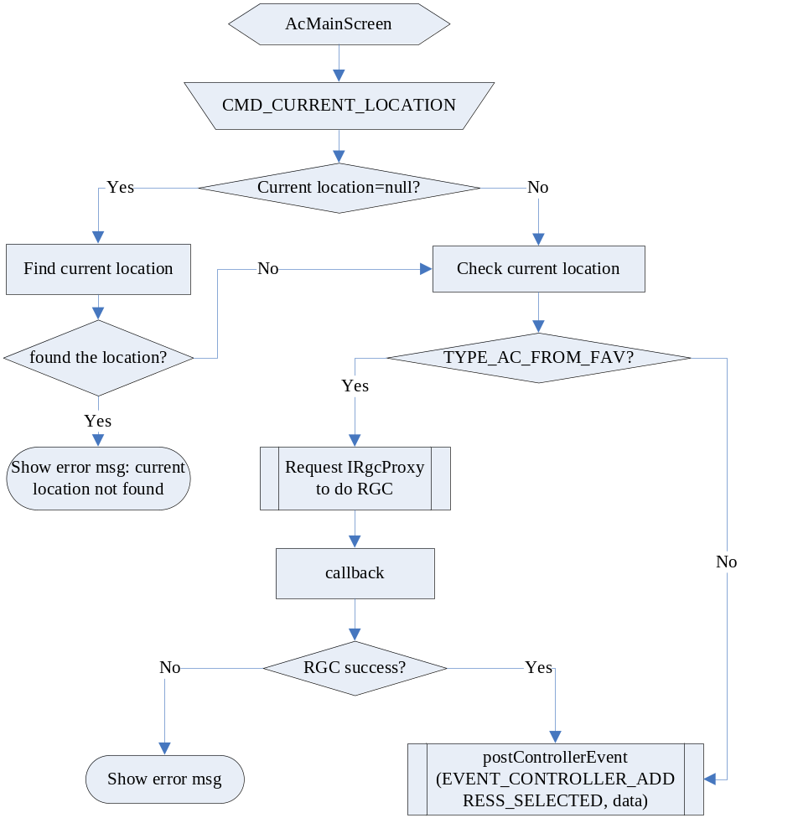

Home/Work/Address flow
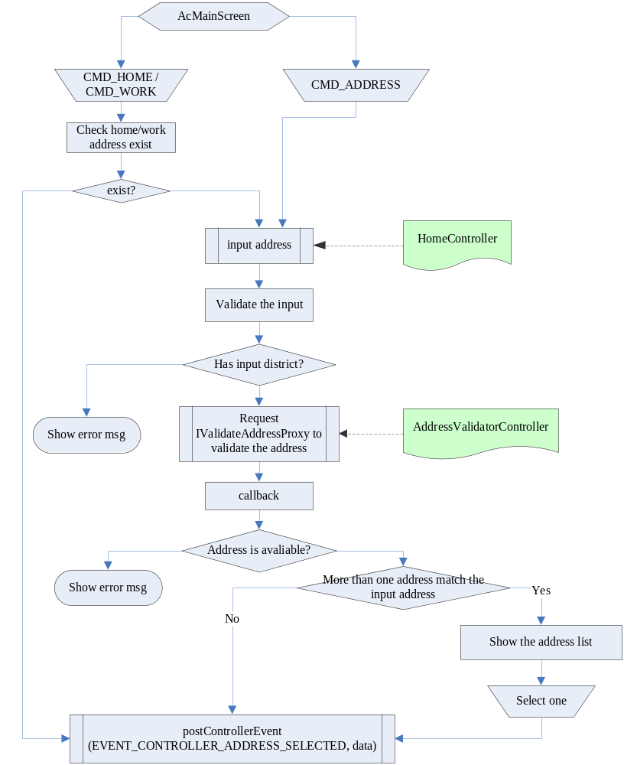

AirportController flow
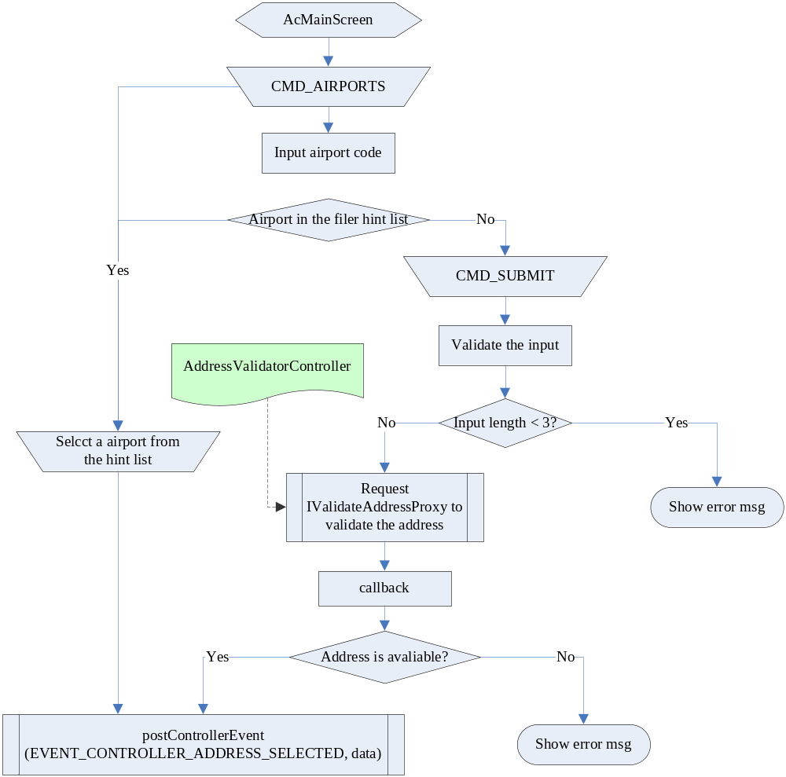

ContactsController flow
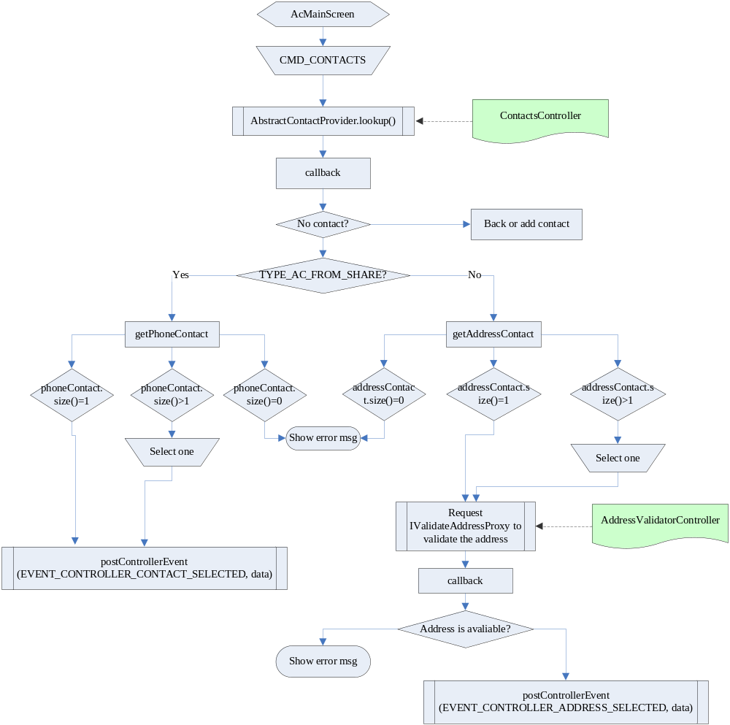

OneBoxSearch

OneBoxSearch flow
